Lab 5.5.2: Access Control Lists Challenge (Instructor Version)

Topology Diagram
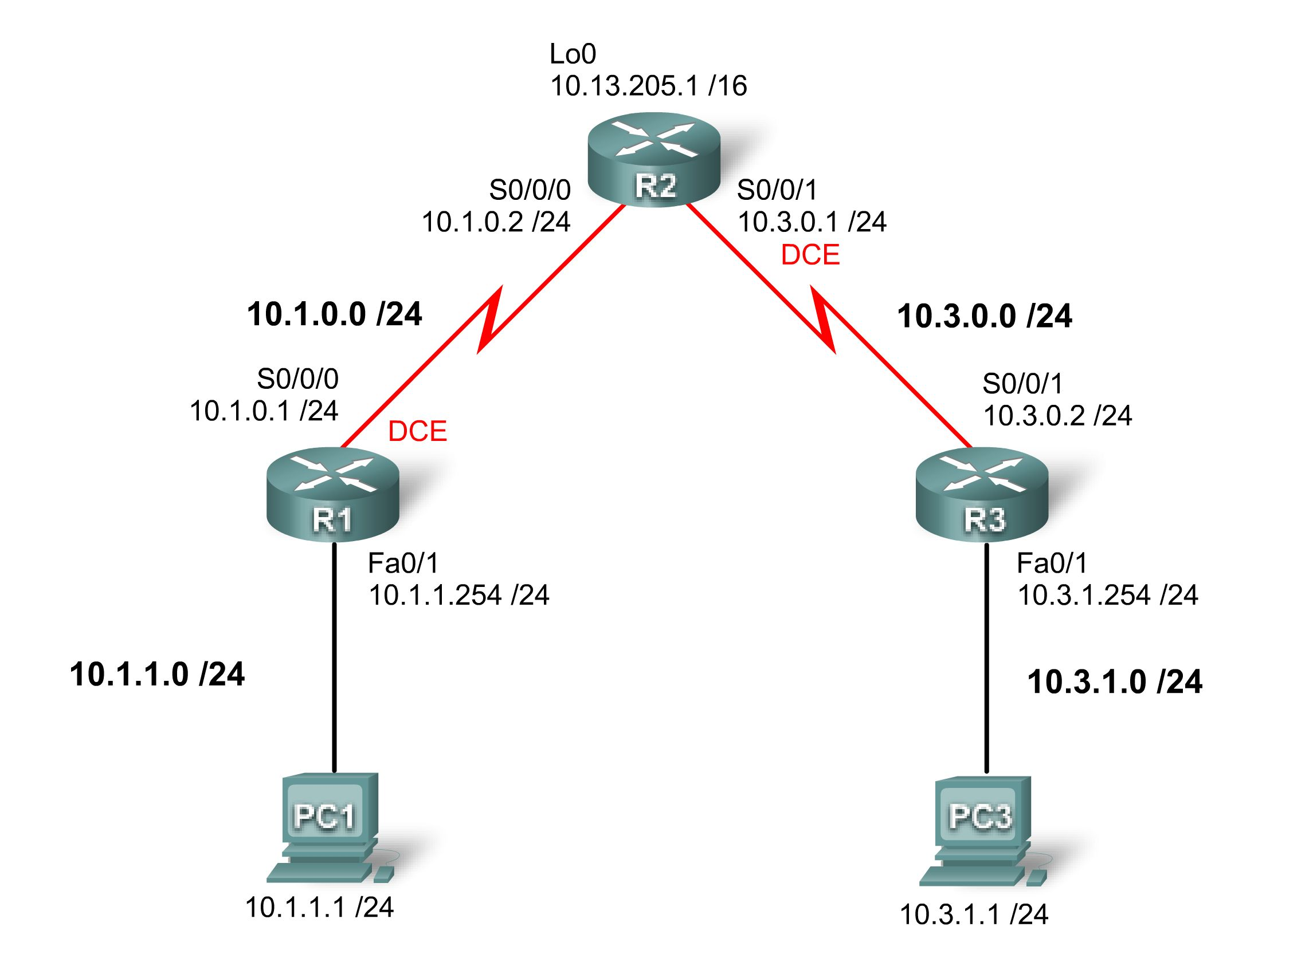

Addressing Table
Device | Interface | IP Address | Subnet Mask | Default Gateway
R1 | S0/0/0 | 10.1.0.1 | 255.255.255.0 | N/A
R1 | Fa0/1 | 10.1.1.254 | 255.255.255.0 | N/A
R2 | S0/0/0 | 10.1.0.2 | 255.255.255.0 | N/A
R2 | S0/0/1 | 10.3.0.1 | 255.255.255.0 | N/A
R2 | Lo 0 | 10.13.205.1 | 255.255.0.0 | N/A
R3 | S0/0/1 | 10.3.0.2 | 255.255.255.0 | N/A
R3 | Fa0/1 | 10.3.1.254 | 255.255.255.0 | N/A
PC 1 | NIC | 10.1.1.1 | 255.255.255.0 | 10.1.1.254
PC 3 | NIC | 10.3.1.1 | 255.255.255.0 | 10.3.1.254

Learning Objectives
To complete this lab:
- Design named standard and named extended ACLs.
- Apply named standard and named extended ACLs.
- Test named standard and named extended ACLs.
- Troubleshoot named standard and named extended ACLs.
Task 1: Prepare the Network
Step 1: Cable a network that is similar to the one in the Topology Diagram.
You can use any current router in your lab as long as it has the required interfaces shown in the topology diagram.
Note: If you use a 1700, 2500, or 2600 router, the router outputs and interface descriptions may appear different.
Step 2: Clear any existing configurations on the routers.
Task 2: Perform Basic Router Configurations.
Configure the R1, R2, and R3 routers according to the following guidelines:
- Configure the router hostname.
- Disable DNS lookup.
- Configure an EXEC mode password.
- Configure a message-of-the-day banner.
- Configure a password for console connections.
- Configure a password for VTY connections.
- Configure IP addresses on all devices.
- Create a loopback interface on R2.
- Enable OSPF area 0 on all routers for all networks.
- Verify full IP connectivity using the ping command.
R1
hostname R1
no ip domain-lookup
enable secret class
!
interface FastEthernet0/1
ip address 10.1.1.254 255.255.255.0
no shutdown
!
interface serial 0/0/0
ip address 10.1.0.1 255.255.255.0
clock rate 125000
no shutdown
!
router ospf 1
network 10.1.0.0 0.0.0.255 area 0
network 10.1.1.0 0.0.0.255 area 0
!
banner motd ^Unauthorized access strictly prohibited, violators will be prosecuted to the full extent of the law.^
!
line con 0
logging synchronous
password cisco
login
!
line vty 0 4
password cisco
login
!

R2

hostname R2
enable secret class
no ip domain lookup
!
interface Loopback0
ip address 10.13.205.1 255.255.0.0
!
interface Serial0/0/0
ip address 10.1.0.2 255.255.255.0
no shutdown
!
interface Serial0/0/1
ip address 10.3.0.1 255.255.255.0
clockrate 125000
no shutdown
!
router ospf 1
network 10.1.0.0 0.0.0.255 area 0
network 10.3.0.0 0.0.0.255 area 0
network 10.13.0.0 0.0.255.255 area 0
!
banner motd ^Unauthorized access strictly prohibited, violators will be prosecuted to the full extent of the law.^
!
line con 0
password cisco
logging synchronous
login
!
line vty 0 4
password cisco
login
!

R3

hostname R3
!
enable secret class
no ip domain lookup
!
interface FastEthernet0/1
ip address 10.3.1.254 255.255.255.0
no shutdown
!
interface Serial0/0/1
ip address 10.3.0.2 255.255.255.0
no shutdown
!
router ospf 1
network 10.3.0.0 0.0.0.255 area 0
network 10.3.1.0 0.0.0.255 area 0
!
banner motd ^Unauthorized access strictly prohibited, violators will be prosecuted to the full extent of the law.^
!
line con 0
password cisco
logging synchronous
login
!
line vty 0 4
password cisco
login
!
Task 3: Configuring Standard ACLs
Configure standard named ACLs on the R1 and R3 VTY lines, permitting hosts connected directly to their FastEthernet subnets to gain Telnet access. Deny and log all other connection attempts. Document your testing procedures.
__________________________________________________________________________________
__________________________________________________________________________________
__________________________________________________________________________________
__________________________________________________________________________________
R1

ip access-list standard VTY_LOCAL
permit 10.1.1.0 0.0.0.255
deny any log
!
line vty 0 4
access-class VTY_LOCAL in
!

R3

ip access-list standard VTY_LOCAL
permit 10.3.1.0 0.0.0.255
deny any log
!
line vty 0 4
access-class VTY_LOCAL in

Attempt to telnet to R3 from PC1, R1, and R2. These tests should fail.
Attempt to telnet to R1 from PC3, R2, and R3. These tests should fail.
Attempt to telnet to R1 from PC1. Test should pass
Attempt to telnet to R3 from PC3. Test should pass.
Task 4: Configuring Extended ACLs
Using extended ACLs on R2, complete the following requirements:
- The LANs connected to R1 and R3 are used for student computer labs. The network administrator has noticed that students in these labs are playing games across the WAN with the remote students. Make sure that your ACL prevents the LAN attached to R1 from reaching the LAN at R3 and that the LAN on R3 cannot reach the LAN on R1. Be specific in your statements so that any new LANs added to either R1 or R3 are not affected.
- Permit all OSPF traffic.
- Permit ICMP traffic to the R2 local interfaces.
- All network traffic destined to TCP port 80 should be allowed and logged. Any other traffic should be denied.
- Any traffic not specified above should be denied.
Note: This may require multiple access lists. Verify your configuration and document your testing procedure.

Why is the order of access list statements so important? __________________________________________________________________________________
__________________________________________________________________________________
Access lists are processed from the top down. If a packet matches a line, the matched action is performed and the actions after that are ignored.

R2
ip access-list extended BLOCK_R1
deny ip 10.1.1.0 0.0.0.255 10.3.1.0 0.0.0.255
permit ospf any any
permit icmp any host 10.1.0.2
permit icmp any host 10.3.0.2
permit icmp any host 10.13.205.1
permit tcp any any eq 80 log

ip access-list extended BLOCK_R3
deny ip 10.3.1.0 0.0.0.255 10.1.1.0 0.0.0.255
permit ospf any any
permit icmp any host 10.1.0.2
permit icmp any host 10.3.0.2
permit icmp any host 10.13.205.1
permit tcp any any eq 80 log

interface serial 0/0/0
ip access-group BLOCK_R1 in
!
interface serial 0/0/1
ip access-group BLOCK_R3 in
Task 5: Verifying an ACL
Test each protocol that you are trying block, and make sure that permitted traffic is allowed. This requires testing ping, HTTP, Telnet, and OSPF.
Step 1: Test R1 to R3 traffic and R3 to R1 traffic.
Ping from PC1 to PC3.
Ping from PC3 to PC1.
Both should fail.

Step 2: Test port 80 access.
To test port 80 functionality, enable the HTTP server on R2:

R2(config)#ip http server

From PC1, open a web browser to the R2 Serial 0/0/0 interface. This should be successful.
Step 3: Verify OSPF routes.
No routes should be lost. Confirm with show ip route.
Step 4: Test ping to R2.
Ping to R2 from R1 and PC1.
Ping to R2 from R3 and PC3.
Both should succeed.
Step 5: Perform other ping tests to confirm that all other traffic is denied.
Task 6: Document the Router Configurations
Configurations

R1

hostname R1
enable secret class
no ip domain lookup
!
interface FastEthernet0/1
ip address 10.1.1.254 255.255.255.0
no shutdown
!
interface Serial0/0/0
ip address 10.1.0.1 255.255.255.0
clockrate 125000
no shutdown
!
router ospf 1
no auto-cost
network 10.1.0.0 0.0.0.255 area 0
network 10.1.1.0 0.0.0.255 area 0
!
ip access-list standard VTY_LOCAL
permit 10.1.1.0 0.0.0.255
deny any log
!
banner motd ^Unauthorized access strictly prohibited, violators will be prosecuted to the full extent of the law.^
!
line con 0
password cisco
logging synchronous
login
!
line vty 0 4
access-class VTY_LOCAL in
password cisco
login
!

R2

hostname R2
enable secret class
no ip domain lookup
!
interface Loopback0
ip address 10.13.205.1 255.255.0.0
!
interface Serial0/0/0
ip address 10.1.0.2 255.255.255.0
ip access-group BLOCK_R1 in
no shutdown
!
interface Serial0/0/1
ip address 10.3.0.1 255.255.255.0
ip access-group BLOCK_R3 in
clockrate 125000
no shutdown
!
router ospf 1
no auto-cost
network 10.1.0.0 0.0.0.255 area 0
network 10.3.0.0 0.0.0.255 area 0
network 10.13.0.0 0.0.255.255 area 0
!
ip access-list extended BLOCK_R1
deny ip 10.1.1.0 0.0.0.255 10.3.1.0 0.0.0.255
permit ospf any any
permit icmp any host 10.1.0.2
permit icmp any host 10.3.0.2
permit icmp any host 10.13.205.1
permit tcp any any eq 80 log

ip access-list extended BLOCK_R3
deny ip 10.3.1.0 0.0.0.255 10.1.1.0 0.0.0.255
permit ospf any any
permit icmp any host 10.1.0.2
permit icmp any host 10.3.0.2
permit icmp any host 10.13.205.1
permit tcp any any eq 80 log
!
banner motd ^Unauthorized access strictly prohibited, violators will be prosecuted to the full extent of the law.^
!
line con 0
password cisco
logging synchronous
login
!
line vty 0 4
password cisco
login
!

R3

hostname R3
!
enable secret class
no ip domain lookup
!
interface FastEthernet0/1
ip address 10.3.1.254 255.255.255.0
no shutdown
!
interface Serial0/0/1
ip address 10.3.0.2 255.255.255.0
no shutdown
!
router ospf 1
no auto-cost
network 10.3.0.0 0.0.0.255 area 0
network 10.3.1.0 0.0.0.255 area 0
!
ip access-list standard VTY_LOCAL
permit 10.3.1.0 0.0.0.255
deny any log
!
banner motd ^Unauthorized access strictly prohibited, violators will be prosecuted to the full extent of the law.^C
!
line con 0
password cisco
logging synchronous
login
!
line vty 0 4
access-class VTY_LOCAL in
password cisco
login
!
Task 7: Clean Up
Erase the configurations and reload the routers. Disconnect and store the cabling. For PC hosts that are normally connected to other networks, such as the school LAN or the Internet, reconnect the appropriate cabling and restore the TCP/IP settings.

